OIS STUDENT INDEX

Slots 2

Overall Course Programme 3

Course Selection 3

Enrolling in Prep Summer School 5

Documents 5

Transcript 5

Report Card 5

Course Schedule 5

Prep Transcript 6

Final Exams 6

Make-up Programme 6

Online Document Request 6

Account Summary 7

Changing Password 8

E-mail 8

Survey 8

GPA Calculator 9

Message System 9

CMS 10

Announcements (Widget) 11

System Settings 12

# Slots

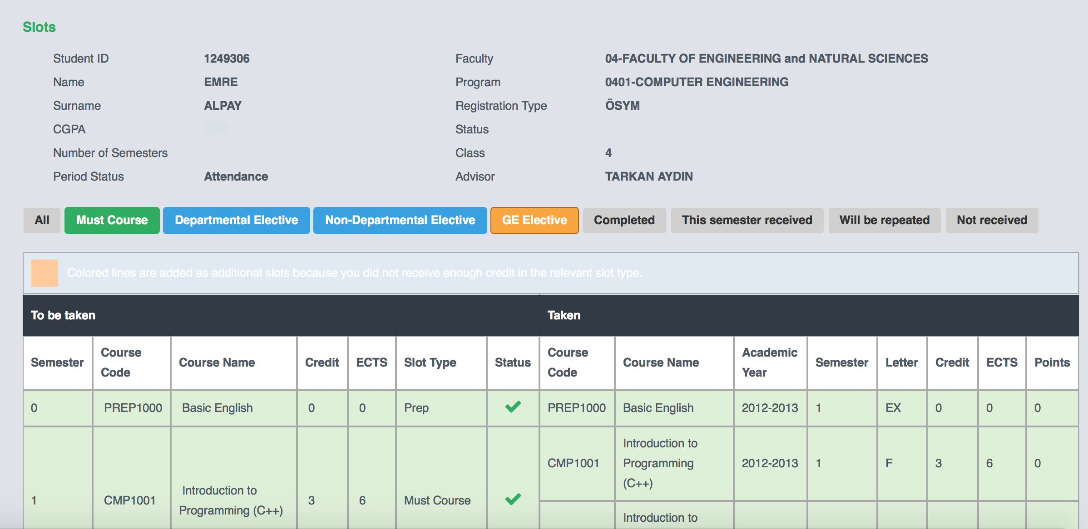

**Table** **1** **–** **Student** **Slots**

When you click on “Slots” on the “Course Procedures” dropdown menu, you will reach a table of your own slots. On the left side, you will find slots that include compulsory and elective courses that you are required to take, and on the right side, you can see the courses that you have taken along with detailed information about those courses. This table displays both the slots of the program that you are enrolled in and the slots of the courses you have already taken or will take. Through this table, you can see information about the course code, course title, and credits, as well as all the information related to your semester, course grades and ECTS credits.

You will see the followings symbols on the table:

= the courses you have completed

= the courses you have not yet taken or the ones you are required to repeat. = the courses which you are currently doing and have not yet finished

Using the same table, you can see the total number of your slots, as well as total number of your completed slots.

# Overall Course Programme

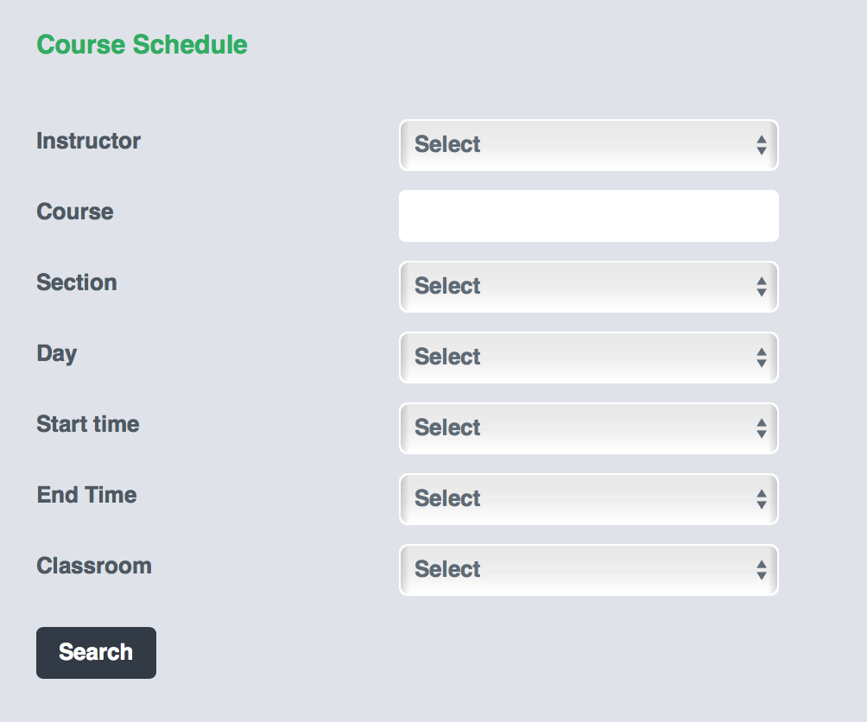

**Table** **2** **–** **Overall** **Course** **Programme** **Search** **Filter**

You can view all courses which are offered at BAU, as well as their schedules through the submenu “Overall Course Programme” under the “Course Actions” menu. By browsing “All Courses”, you can check to see if the elective courses that you are planning to take are actually suitable for you , and thus guide you in making your course selections.

As you will also see in the table, you can search for specific courses by selecting the relevant field(s).

# Course Selection

During the enrolment dates designated in the Academic Calendar, you can select courses using the “Course Selection” tool, which you can reach from the “Course Procedures” menu. Once you accept the “Terms and Conditions” that will appear in a new window when you log in, you will be able to proceed with your course selections.

We first need to mention that some courses may automatically be selected for you by the system itself due to the framework of BAU regulations.

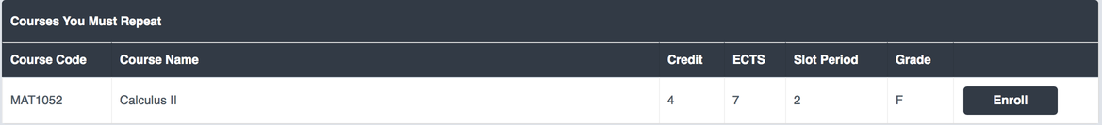

**Table** **3** **–** **Courses** **to** **Retake**

Since you are required to retake the courses for which you previously received “F, NA, W”, these courses will automatically appear in the “Courses to Retake” table. You can select the relevant course from this table.



**Table** **4** **–Courses** **You** **Have** **Not** **Taken** **Yet**

The courses which you have never taken before are listed in this table. You can click “Add Course” to take the course which you want.

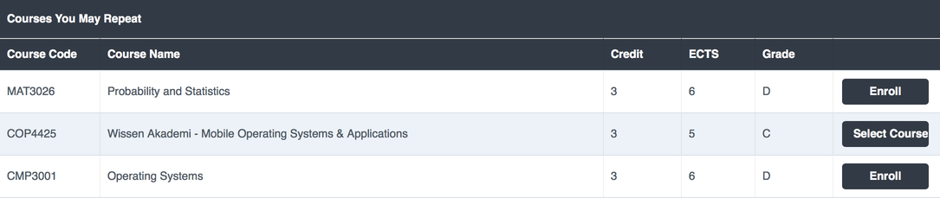

**Table** **5** **–** **Courses** **You** **Can** **Retake**

If you have previously received a passing grade for a course, yet you want to raise your passing grade, you can find the relevant course from the “Courses You May Retake” table.

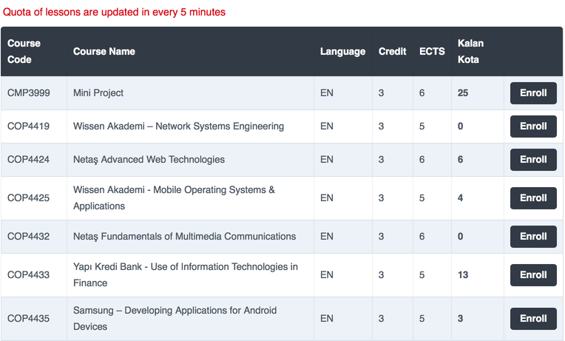

**Table** **6** **–** **Elective** **Pool**

By clicking on the “Select Course” link, you can choose the course which you wish to take from a pool of elective courses. It is possible to view all of the elective courses available in every department of the university.

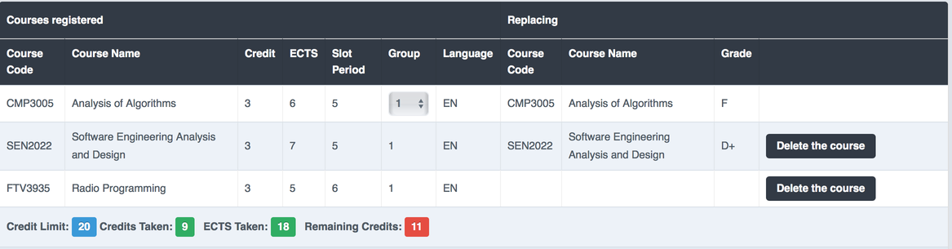

**Table** **7** **–** **Courses** **You** **Have** **Selected**

You can view your course selections along with the credit, ECTS, and section (group) information of those courses in your preferred language. You can also check your credit limit, obtained credits and remaining credits. Once your credit limit is full, the system will not allow you to take any new courses. If you change your elective course that you have already taken with a new one, information related to the former one will be displayed in the “Substitute Courses” table.

If you have received an “F”, “NA”, or “W” for a course before and you are retaking it, the system will allow you to change the section of these courses.

# Enrolling in Prep Summer School

From the “Course Procedures” menu, select “Prep School Summer Programme Course Registration” to view the list of courses offered at summer school.

# Documents

This menu allows you to receive information, as well as reach and print a variety of personal documents. These documents are uploaded to the system only for your own personal use. They have no official validity.

# Transcript

This document reveals an extensive record of the courses which you have taken and the grades you have received so far. You can also find your GPA and semester average in the transcript. Total credits and ETCS credits can also be found in this document.

# Report Card

The report card is a document that shows your end of semester grade. It is available at certain dates specified in the academic calendar.

# Course Schedule

Your weekly class schedule and information related to your advisor are to be found in this document. It informs you about the course code, title, venue, date, time and the lecturer.

# Prep Transcript

This document is available only for our prep students on certain dates stated in Academic Calendar.

# Final Exams

This document includes information about the days, times, and venues of your final exams. It is available on the dates specified in the Academic Calendar.

# Make-up Programme

You can reach the Make-up Exam Calendar through “Make-up” field of the “Documents” menu.

# Online Document Request

From this screen, you can request the following documents: Student Document, Transcript, Language Proficiency Document, Prep School Grade Document, and Prep School Transcript. On the same screen, you can also see the list of documents which you have previously requested.

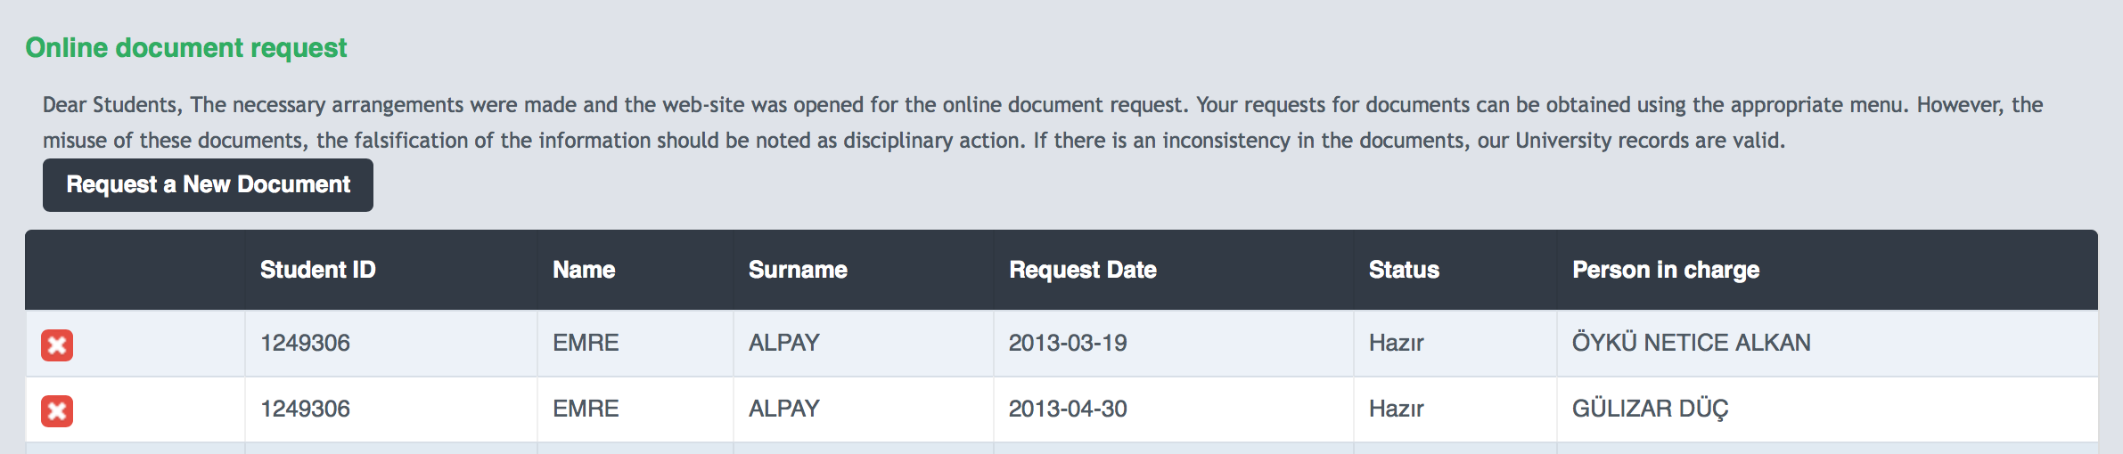

**Table** **9** **–** **Online** **Document** **Follow** **–Up**

Using the “Request New Document” menu, you can specify the type, the number and the language of the document which you request. You can also specify what you will use this document for.

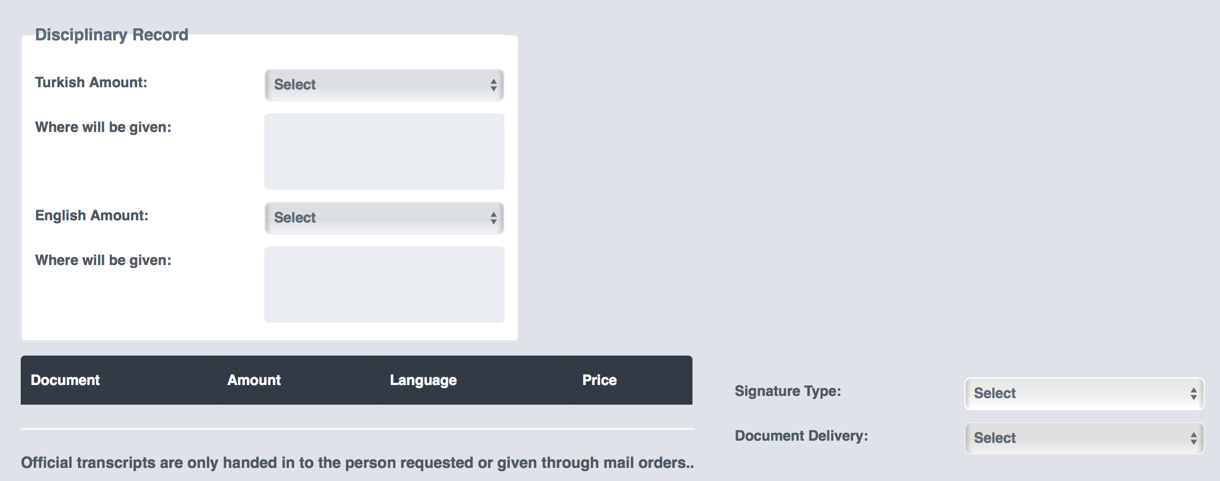

**Table** **10** **–** **Student** **Document** **Request**

Once you finalize your request, you can get the updates on your document’s current status.

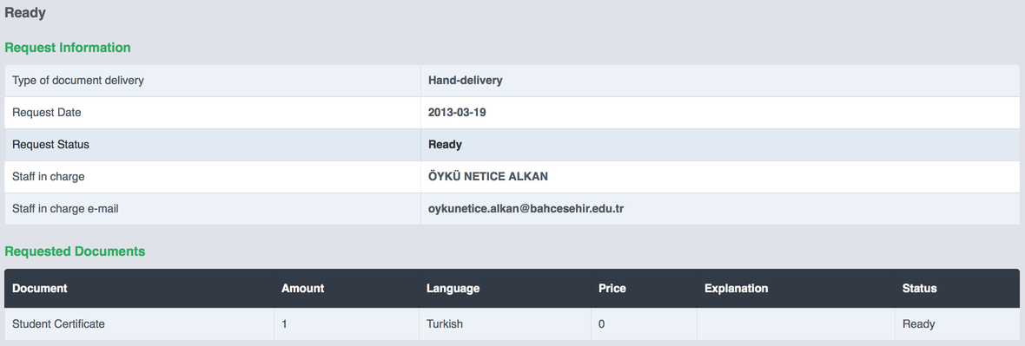

**Table** **11–** **(Request** **Summary)**

Using this table, you can get updates on your document. You can also find the contact details of the Student Affairs personnel who is responsible for preparing the document.

# Account Summary

Information regarding your finances can be found here. You can track the payments that you have made or you will make in the future.

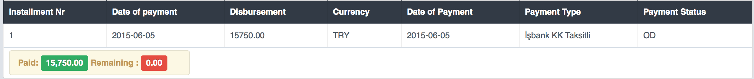

**Table** **12–** **(Payments** **Summary)**

# Changing Password

You can update your password using the “Change Password” link in the “Other Actions” menu. Make sure your new password consists of at least eight characters and that it does not have any Turkish characters in it.

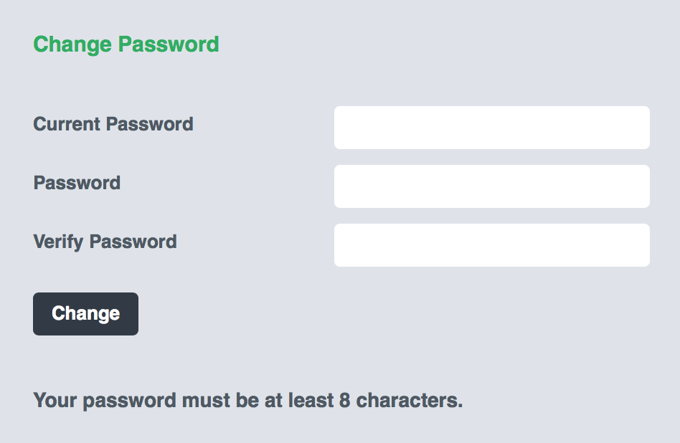

**Table** **13** **–** **Changing** **Password**

# E-mail

Our student e-mails have been transferred to Gmail servers. You can reach your account using the options below:

• via Gmail.

To log in to your e-mail account, you need to type your full username (for example: [name.surname@stu.bauinternational.edu.ge)](mailto:name.surname@stu.bauinternational.edu.ge)). As your OIS password is the same as your e-mail password, you need to use your OIS password while you are logging in your e-mail account. If you change your OIS password, your e-mail password will automatically be updated. If you have trouble logging in to your e-mail account, first try logging in to OIS to update your OIS password.

# Survey

Under the “Other Settings” menu, you can click on “Surveys”. During the dates that the BAU Rectorate has announced, you can do course and supervisor performance evaluation surveys, as well as give feedback on the courses and the lecturers. Also, you can take a satisfaction survey, which you can reach from the “Other Surveys” menu and leave your comments.

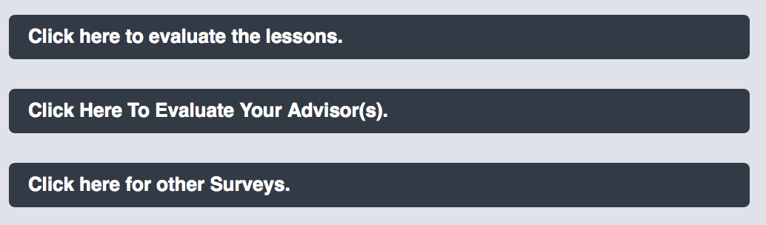

**Table** **14** **–** **Survey** **/Evaluation**

# GPA Calculator

This calculator is designed to provide students with an ***estimate*** of their GPA. On this page, you can enter the grades you think you will receive for the courses which you are currently taking. Then you can get an estimated End of Term average, as well as an estimated cumulative GPA. Also, you are able to save the grades which you have entered and reach them later on.

# Message System

First we need to make it clear that the Message System is different from the E-Mail System. These two systems are often confused. The message system is a communication platform that allows you to contact your professors and advisors. You can also send messages and file attachments to your

professors with this system. Using the “ “ icon, you can send the same message to multiple recipients .

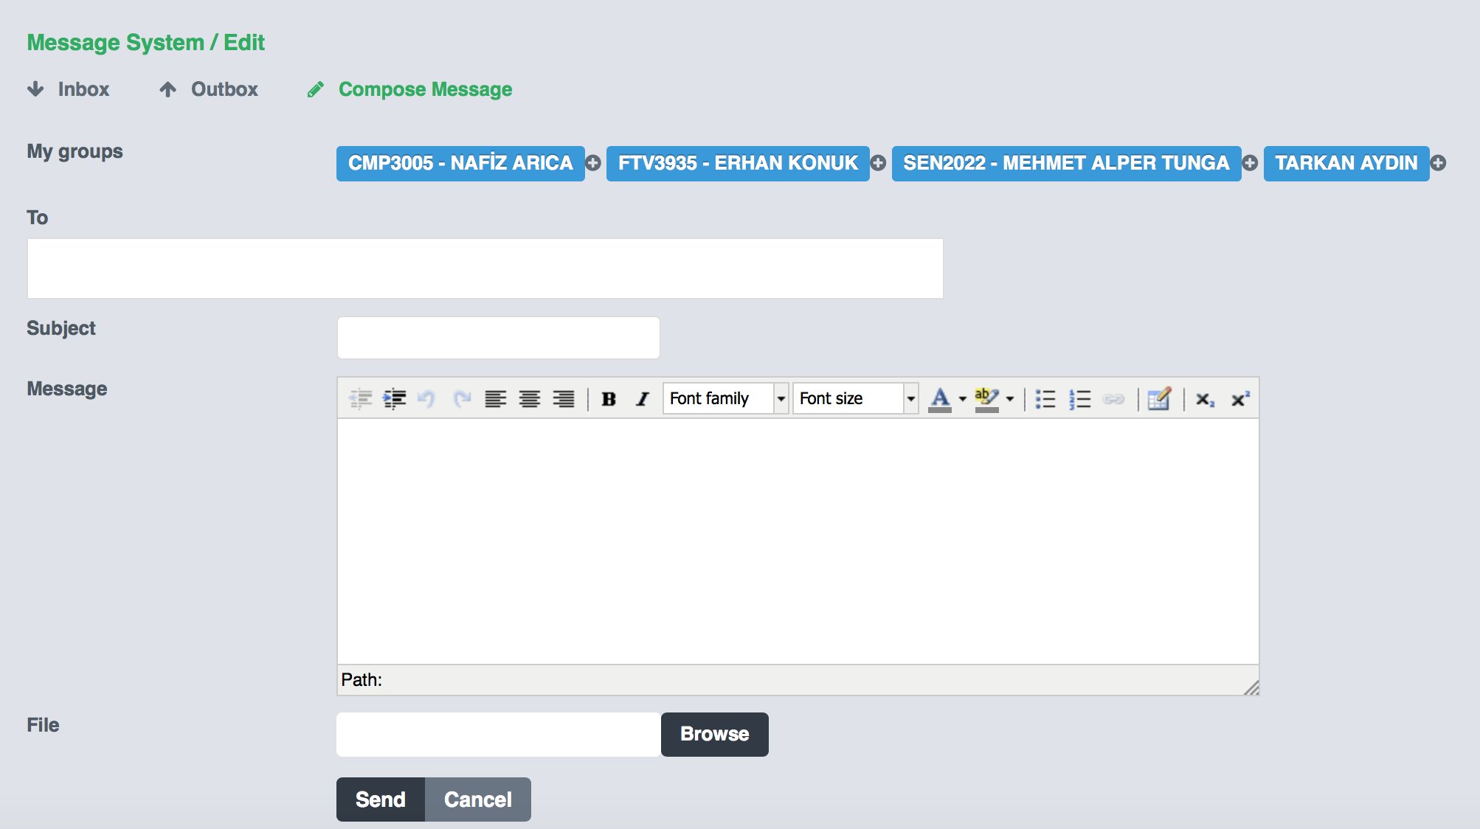

**Tablea** **15** **-** **Writing** **a** **Message**

You can also reach this module through the “Message Box” widget on your main page.

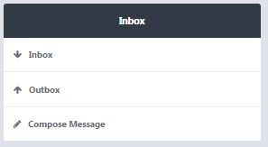

**Table 16** **–** **Massage** **Box** **Widget**

# CMS

Via the CMS widget on your main page, you can reach the syllabi, homework assignments, announcements, attendance records and class notes for your courses.

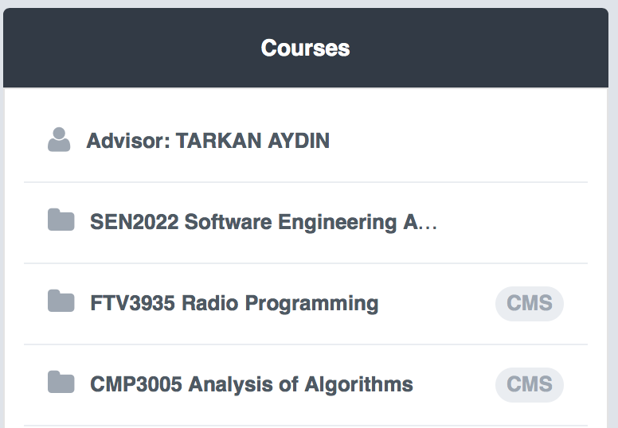

**Table** **17** **–** **Courses** **Widget**

To be updated on the latest activities from LMS, just enter your e-mail address to the section entitled “Do you wish to receive updates from LMS on the uploaded announcements, lecture notes, homework assignments, etc.” Once you enter your address, any news regarding the latest uploads to LMS of lecture notes, announcement, etc. will automatically be sent to your e-mail account.

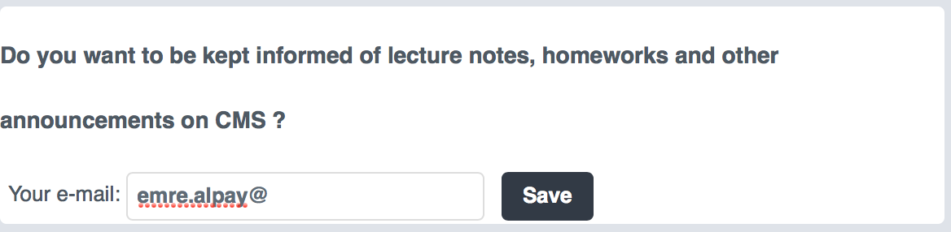

**Table** **18** **–** **LMS** **E-Mail** **Identification**

Announcements regarding courses or any other subject that a lecturer/professor has made are to be found under “Announcements (LMS)” on your main page.

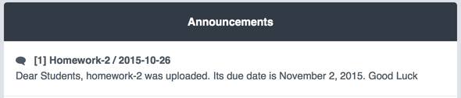

**Table** **19** **–** **LMS** **Announcements**

The syllabus contains a weekly schedule of the subjects to be covered in class, as well as the required course materials.

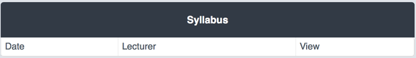

**Table** **20** **–** **Syllabus**

Course instructors can upload lecture notes here. Click on “Download” to save the course notes and other course materials.

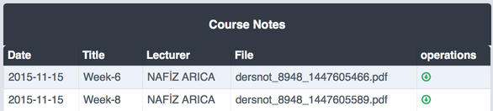

**Table** **21** **–** **Lecture** **Notes**

Under “Assignments”, you can view course assignments, and through “Actions”, you can submit your assignments up until the deadline that your course instructor has specified.

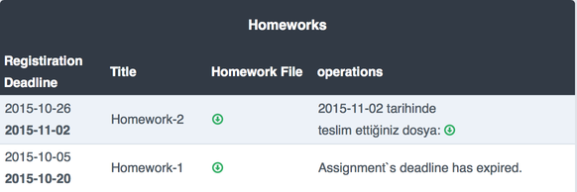

**Table** **22** **–** **Assignme****nts**

# Announcements (Widget)

This is the platform where you can follow the announcements to be made throughout the term.

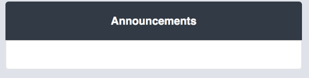

**Table** **23** **–** **Announcements** **Widget**

# System Settings

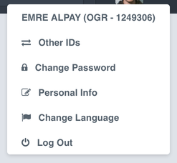

**Table** **24** **–** **System** **Settings**

To reach your system settings, click on your profile photo in the upper-right corner of your home page. From this tag, you can easily access your other accounts (double major, minor), reset your password, change the language preference of your system or leave the system entirely.